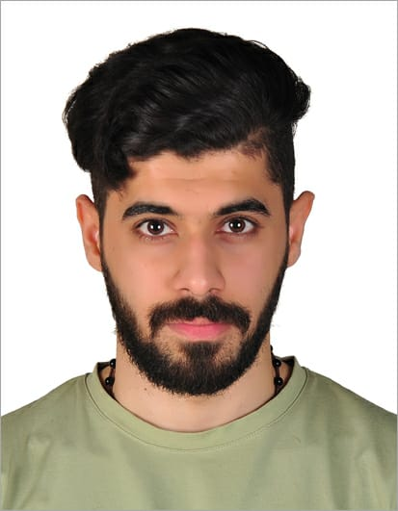
- Name Salman Hasan Abdulla Ali
- Nationality Bahraini
- Date of Birth 10/5/1994
- CPR No 940505444
- Marital Status Single
- Phone No 38006859
- Email Sha-@msn.com
- Address House 1215, Road 7519, Block 575 Al Janabiyah
Objectives

To work in a challenging environment that maintains high professional standards, fosters personal growth, provides the opportunity for continuous learning and expects quality results.

Educational Qualification:

- High School Certificate (Electronic) – Jidhafs Secondary School (August 2009 - October 2011).
- Diploma in IT – Bahrain Training Institute (Februarys 2012 – Februarys 2014).
Courses:

- Microsoft Official (Word) – In Al Moalem Institute - (25 March 2017).
- English Foundation – In Al Mashreq Training - (7 February 2016 – 13 March 2016).
- Retail Sales – Horizon HDC - (27 December 2017 – 29 December 2015).
- Customer Service – In Horizon HDC - (21 December 2015 – 23 December 2015).
- Business Etiquette – In Genetech Training - (24 December 2015).
- Fundament of Customer Service – In Horizon HDC - (2 December 2015 – 20 December 2015).
- Business Etiquette – In Horizon HDC - (7 December 2015 – 9 December 2015).
- Elementary English – In Incredible English Institute - (8 December 2014 – 26 February 2015).
- Work Placement Programme – In Specialization of Electrical - (20 September 2011 – 20 October 2011).
Experience

- Customer Service & Cashier & Visual Merchandising – (Red Tag / Twenty) in Bahrain Mall and Ramli Mall – VM - (29 April 2015 – Current).

Personal features:

- Open minded and accept other people's points of view.
- Able to work under extreme work pressures and long working hours.
- Business driven, focused and hard working.
- Effective team player with outstanding communication and interpersonal skills.
- Advanced time management & capable in dealing with stress.
Skills

- Computer literacy: MS Office applications (word, PowerPoint And excel)
- Languages:
  - Arabic. – Native
  - English, speaking and writing. – good
- Driving License: Valid

